Aung Kaung Khant

aungkaungkhent@gmail.com

Web Production

Vacancy Links

Table of Contents

1. Introduction 1

2. Critical review of Chapter 1 of the referenced book 1

3. Applying of Ideas from the book 2

3.1 Iterative Design and thinking 2

3.2 Defined usability goals and objectives 2

Paper Prototyping 2

4. Comparisons with other web apps 3

5. Conclusion 5

Bibliography 5

# 1. Introduction

Vacancy Links is a web application that offers part time jobs from some townships of Yangon. Users can search jobs by location and job title. Users don’t have to create account on the website if they have their own Gmail account. After they found the proper job and applied the vacancy, they have to wait till the employer contact. After the agreement of both employee and employer, the pending job will disappear.

As it is a kind of recruiting website, it must make the users feel absent of the frustration to use it (Rubin & Chisnell, 2008). Besides, the web app being usable will, somehow, increase the amount of hard core users of the website in a considerable amount. The opposite facts of the mentioned above can be considered as the disadvantages of a website not being usable. To prevent the disadvantages, I searched and read a useful book and then apply the knowledge from analysing the book. The following is the critical review of Chapter 1 of the referenced book.

# 2. Critical review of Chapter 1 of the referenced book

The book named “Handbook of Usability Testing: Second Edition” is written by Jeff Rubin and Dana Chisnell. I got a lot of knowledge after reading the book and applied the knowledge to Vacancy Links web application. The aim of the book is to get a qualified app through the usability testing.

To conclude the chapter1 of the book,

1. The true meaning of usability
2. Reasons why some apps are less usable than the normal ones
3. Reasons why some apps are more usable than the normal ones
4. Steps to build a usable app

# 3. Applying of Ideas from the book

As aforementioned, I got some ideas to develop my web application during the phase of implementation. The ideas are iterative design and testing, and defined usability goals and objectives along with paper protyping.

## 3.1 Iterative Design and thinking

True iterative design leads to the absolute overhaul and rethinking of a design, via early testing of design ideas and conceptual models. Unless the designers think about to prepare for such a huge step, the impact of iterative design becomes just cosmetic and minimal. That’s why I spent about 1 weeks to get Vacancy Links UI.

## 3.2 Defined usability goals and objectives

To get a useful design, the process must be structured and systemic, starting with high-level goals and moving to specific objectives. Otherwise, the goal is not achievable. The reasons why makes products usable may contain as following.

* Usefulness
* Efficiency
* Effectiveness
* Satisfaction
* Accessibility

## Paper Prototyping

Paper prototyping is a process that helps developers to create software that meets users’ expectations and needs by drawing page flow and mock of pages. I didn’t draw in papers but I draw mocks up in prototyping tool named Framer.

# 4. Comparisons with other web apps

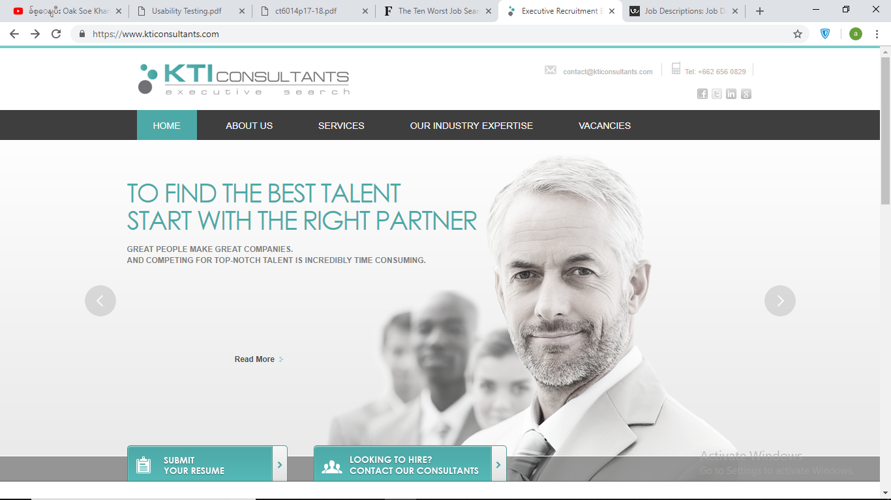

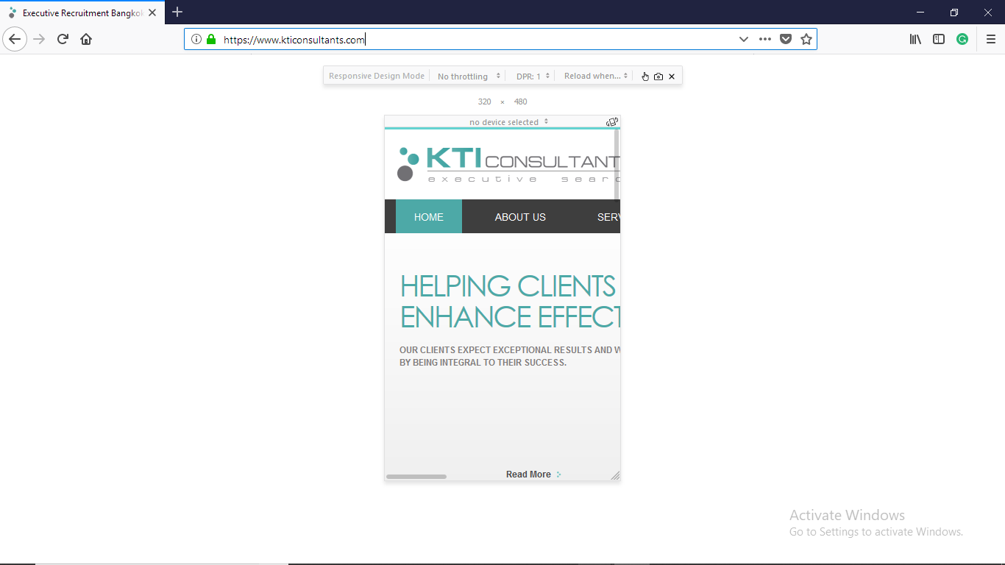

The KTI consultant website is neither responsive nor cross-platform. Besides, you can’t see the recently added jobs unless you search hardly in the search page. In my website users can always check the recently added jobs or last added jobs by checking just home page. Besides, may be users like the details of UI design. But it is certain that they will become weary of searching proper jobs for them.

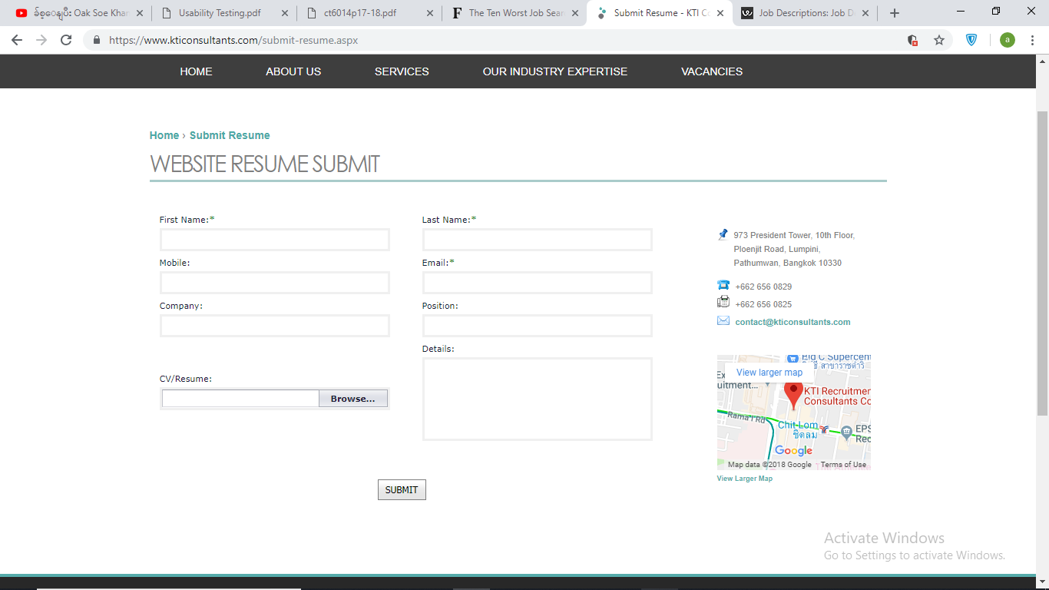

When users want to apply jobs, they have to fill the data every time they try to apply. That is annoying. In vacancy links, users only need to click apply button and then just have to log in Gmail for their Gmail IDs to be in the database. Besides, when users want to apply jobs without willing to check details, they still have to pass through detail page. Only apply button is there.

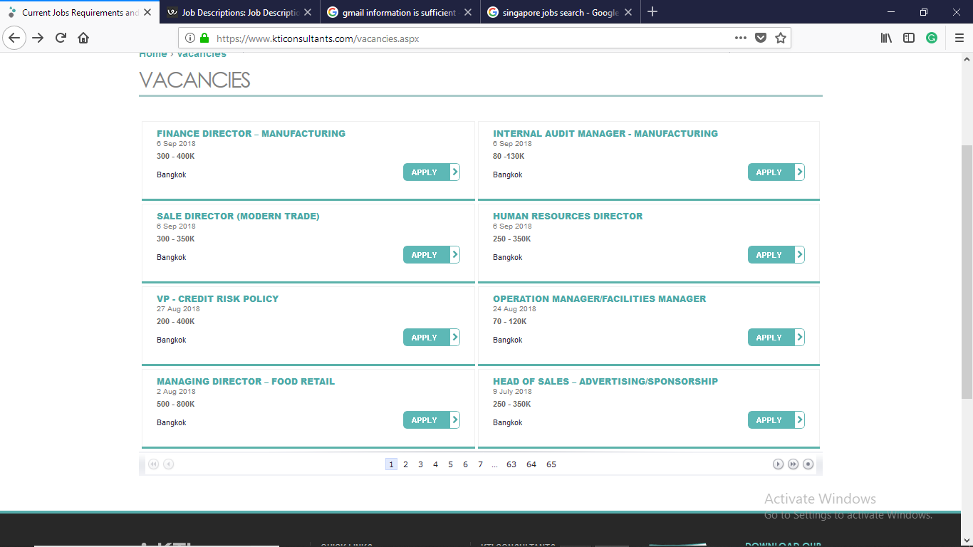

The following is one of best Myanmar job search website. Though it is one of the best. It is not completely responsive. Users won’t get full satisfaction because of just one imperfection.

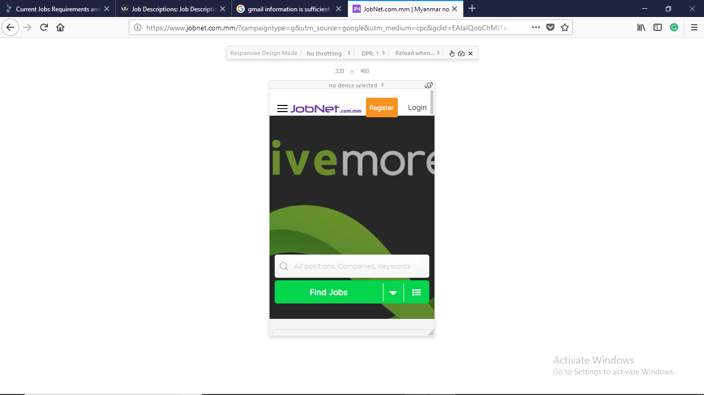

# 5. Conclusion

Analysing the results after applying ideas from the book, it is prominent that the book impacts positively on the vacancy links. Nonetheless, if I could get more time, I would like to try my best for my app to be one of the best real-life Myanmar Job search web application.

# Bibliography

Rubin, J. & Chisnell, D., 2008. *Handbook of Usability.* 2nd ed. Indianapolis: Wiley Publishing, Inc..